# Robot Programming Guide and Analysis to understand the problem:

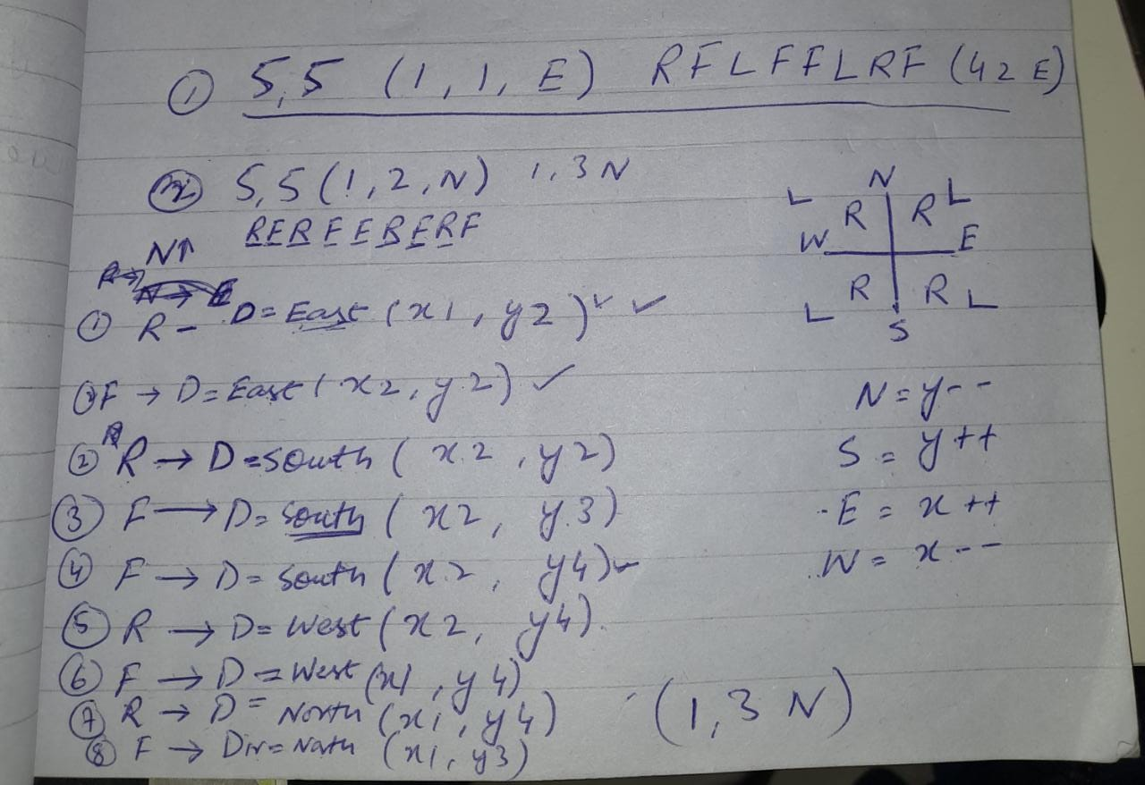

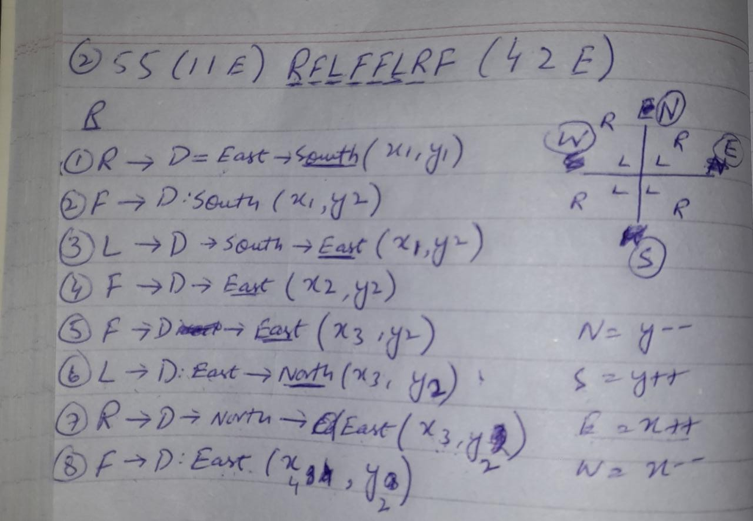

**NORTH**

Right

Right

Left

Left

* NORTH: Y--

Right

Right

Left

Left

**SOUTH**

* SOUTH : Y++

**WEST**

**EAST**

* EAST: X++
* WEST: X--

